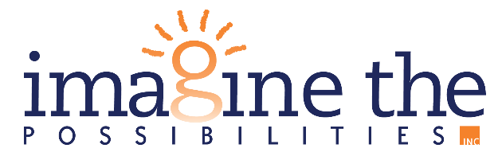

January 28, 2025

FOR IMMEDIATE RELEASE
Contact Person: Cheryl Plank
(563) 652-5252 x1006
cplank@imagineia.org

IOWA CELEBRATES TWO DISABILITY SERVICE FUNDING AWARDS

The state of Iowa continues to remain integral for disability services and advocacy in the United States. The hard work and support of our providers and legislatures has paid off, as the Iowa Department of Health and Human Services (HHS) received one of 14 National Expansion of Employment Opportunities Network (NEON) project awards from the US Department of Labor, Office of Disability Employment Policy (ODEP). With this funding award, Iowa HHS will aim to fund structural changes in Day Habilitation services in order to promote inclusion and integrated employment. The funding will also assist with building training modules for Benefits Liaisons who assist youth with disabilities. Iowa HHS will be partnering their efforts with Imagine the Possibilities, the Iowa Developmental Disabilities Council, Vocational Rehabilitation Services, the Iowa Association of People Supporting Employment-First (APSE), and the University of Iowa Center of Excellence for Behavioral Health (CEBH). The project began in December of 2024 and will conclude August 29, 2025.
Additionally, the National Association of Councils on Developmental Disabilities (NACDD) has awarded five State DD Councils $15,000 through the Bridging Aging & Disability Network Enhanced Funding Opportunity, which is funded by the Administration on Community Living. The five states receiving the additional funds include: Iowa, Alabama, Hawaii, Michigan, and New Mexico. The funding will be used to expand and strengthen the aging & disability networks’ efforts to support aging individuals with I/DD. All 17 states in the NACDD network will each receive a baseline of $10,000 and 40 hours of Technical Assistance/Subject Matter Expert help towards projects.
The state of Iowa being one of few recipients of these funding awards means that Imagine the Possibilities and agencies like ours can not only continue to provide exceptional care to individuals with disabilities but now have the monetary assets to support new advancements, trainings, supplies, and more. Imagine the Possibilities is grateful to provide services in the state of Iowa where we are once again recognized and awarded for exemplary service and advocacy for individuals with disabilities.
For more information on Imagine the Possibilities, check out www.imagineia.org.

###

