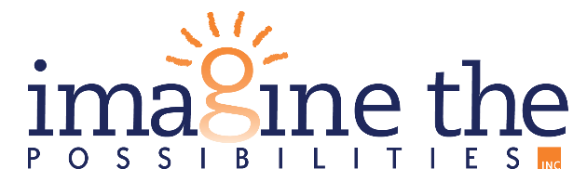

**July 19, 2024**

**FOR IMMEDIATE RELEASE**

**Contact Person: Michaela Morris**

**(563) 652-5252 x3110**

[**mmorris@imagineia.org**](mailto:mmorris@imagineia.org)

**IMAGINE THE POSSIBILITIES WINS BUSINESS OF THE YEAR**

DEWITT, IA – On June 20th, 2024, business and community leaders of DeWitt, Iowa, gathered to celebrate the incredible year of business and community at the Year in Review event! Leading up to the event, many incredible businesses were nominated for awards celebrating the impact they have made on the community. Imagine the Possibilities was honored to be chosen as the 2024 Business of the Year!

Congratulations to our DeWitt team for being selected as the 2024 Business of the Year at the DeWitt Member Choice Awards! This is an incredible honor that so many on this team have worked tirelessly to achieve.   
Most importantly, we are excited to continue positively impacting our communities and truly serving people   
each day. Today, we dedicate this award to the heartbeat of our organization – our direct support staff – who all compassionately and humbly serve people each day so they can reach their goals and be actively involved in their community.

Imagine the Possibilities is a nonprofit organization that serves individuals with disabilities across the state of Iowa. As an organization, Imagine the Possibilities is on mission to **empower people to reach individual achievement across the spectrum of life**. This is done through equipping people with the skills and opportunities necessary for success.

For more information on Imagine the Possibilities, check out [www.imagineia.org](http://www.imagineia.org).

###