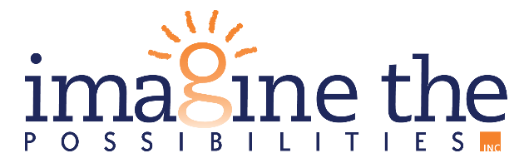

**July 19, 2024**

**FOR IMMEDIATE RELEASE**

**Contact Person: Michaela Morris**

**(563) 652-5252 x3110**

[**mmorris@imagineia.org**](mailto:mmorris@imagineia.org)

**IMAGINE THE POSSIBILITIES RECEIVES STELLAR IPS FIDELITY REVIEW**

BURLINGTON, IA – In May 2024, our Individual Placement and Support (IPS) services were reviewed by a Fidelity team. IPS services focus on helping people who live with serious mental illness, co-occurring substance use disorders, and/or complex needs be given the support they need to be employed with a career they love. Agencies providing IPS services are committed to setting competitive employment as an attainable goal for people with behavioral health conditions.

Fidelity reviews are conducted at the IPS Program locations to ensure the best implementation of these evidence-based practices and to provide recommendations for improvement. In May, the Fidelity Team conducted an onsite review, and we are happy to say we have met "Good Fidelity” for the second year in a row. In addition, the United Way of Southeast Iowa has approved the final funding for the 2025 Annual Campaign year and will be designating $30,000 to the IPS program. This is incredible news!

Imagine the Possibilities is a nonprofit organization that serves individuals with disabilities across the state of Iowa. As an organization, Imagine the Possibilities is on mission to **empower people to reach individual achievement across the spectrum of life**. This is done through equipping people with the skills and opportunities necessary for success.

For more information on Imagine the Possibilities, check out [www.imagineia.org](http://www.imagineia.org).

###